USER DOCUMENT OF SPS

# Introduction

This documentation includes a description of the system functions and capabilities, and step-by-step procedures for system access and use.

Firstly, the computer has to connect with local SQL server. All data is collect from dumb database from local server so they can be different in reality. The website data can be modified later for real data compliment.

The website uses some online resources so running website offline may effect to website interface.

The website have been create as a mock-up, not the final version.

# Task Analysis

Site Map

1. LogIn Page

Unsuccessful to verify account via MS server, so the login page work with database in local server.

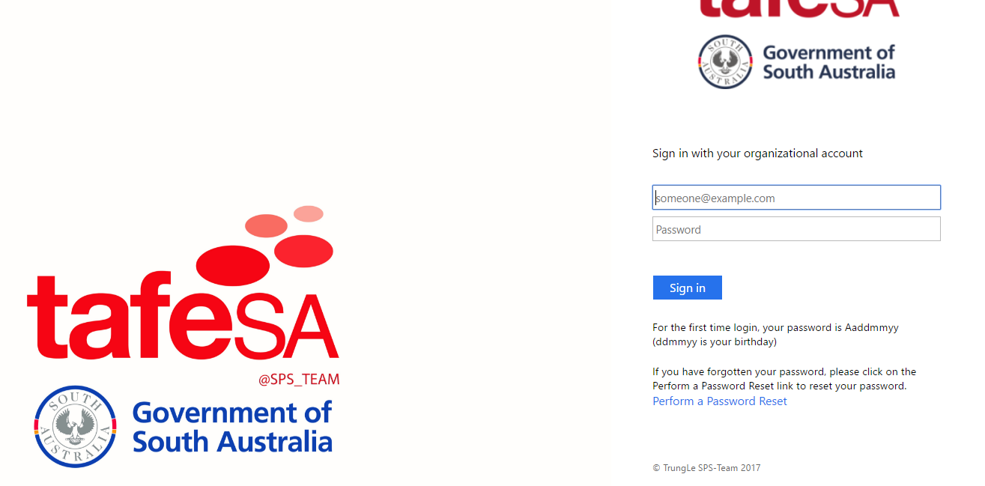

* Have JavaScript to verify inputs
* Include link to retrieve password when user forgot

1. Main Page

Master page menu

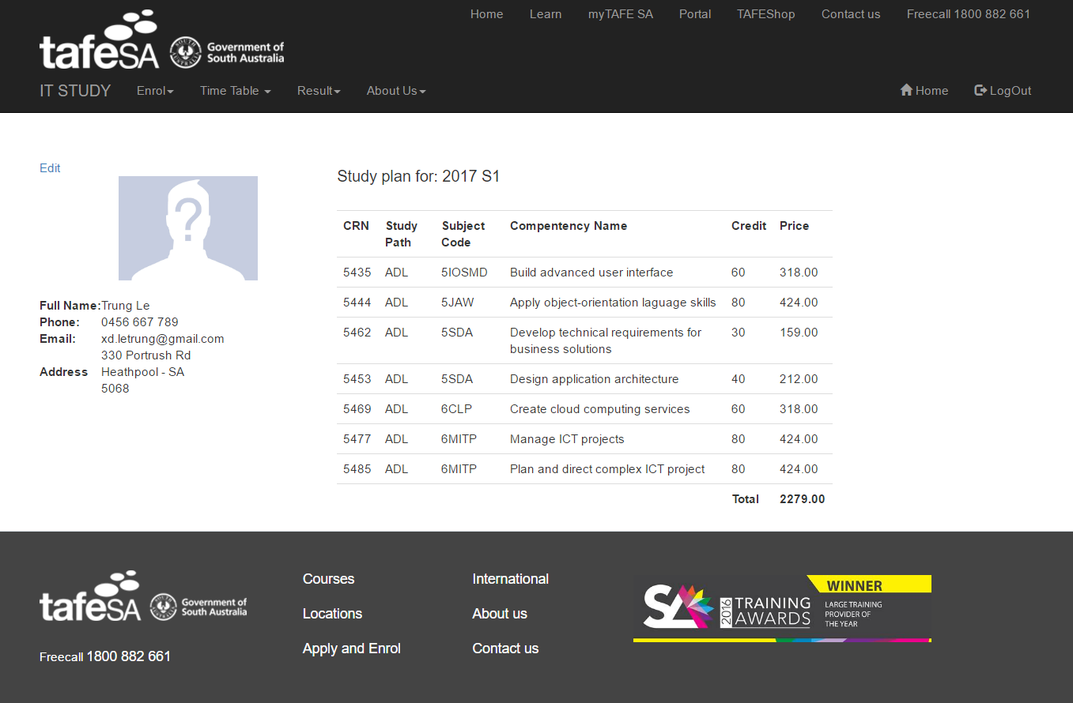

Current registered study plan

Footer

Profile div session

Main page menu

* Page is designed similar to TAFE SA website
* Menu bar:

For enrolment 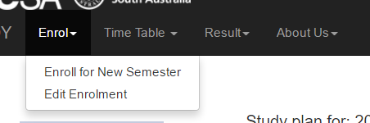

For timetable 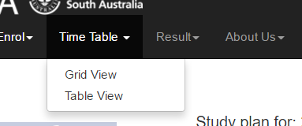

For result 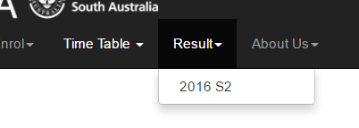

For more information 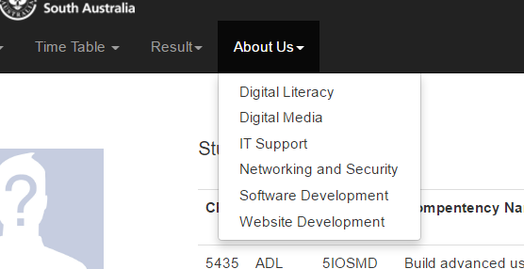

1. Enrol page

* Enrol for new semester

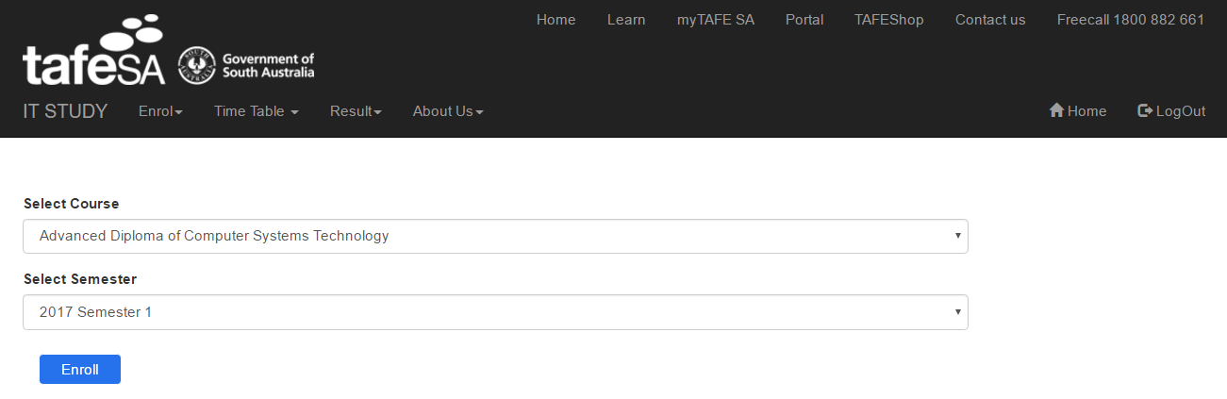

* Edit enrolment

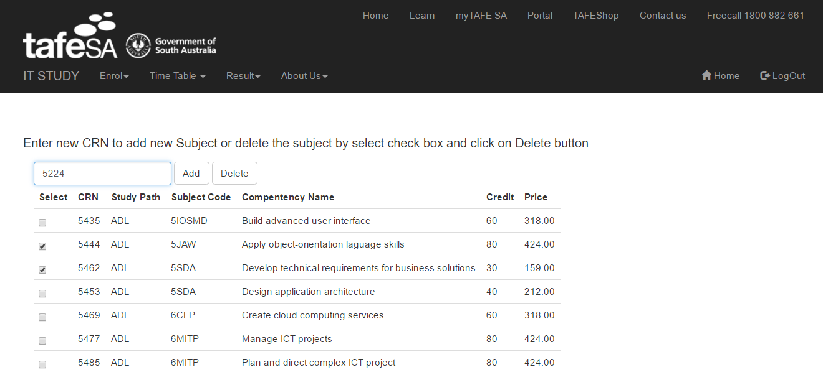

1. Timetable

Time table got data from dumb database from local service, the table view is set with a picture to be showed as a mock up.

* Grid view

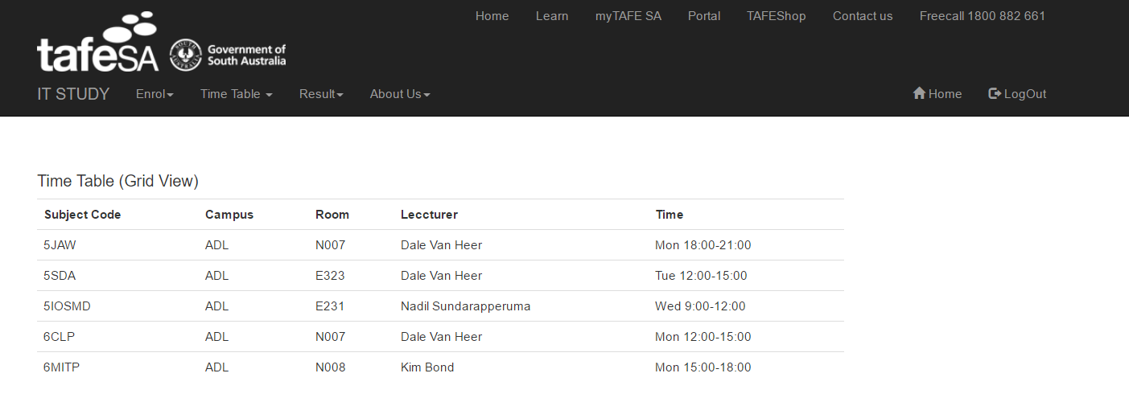

* Table view

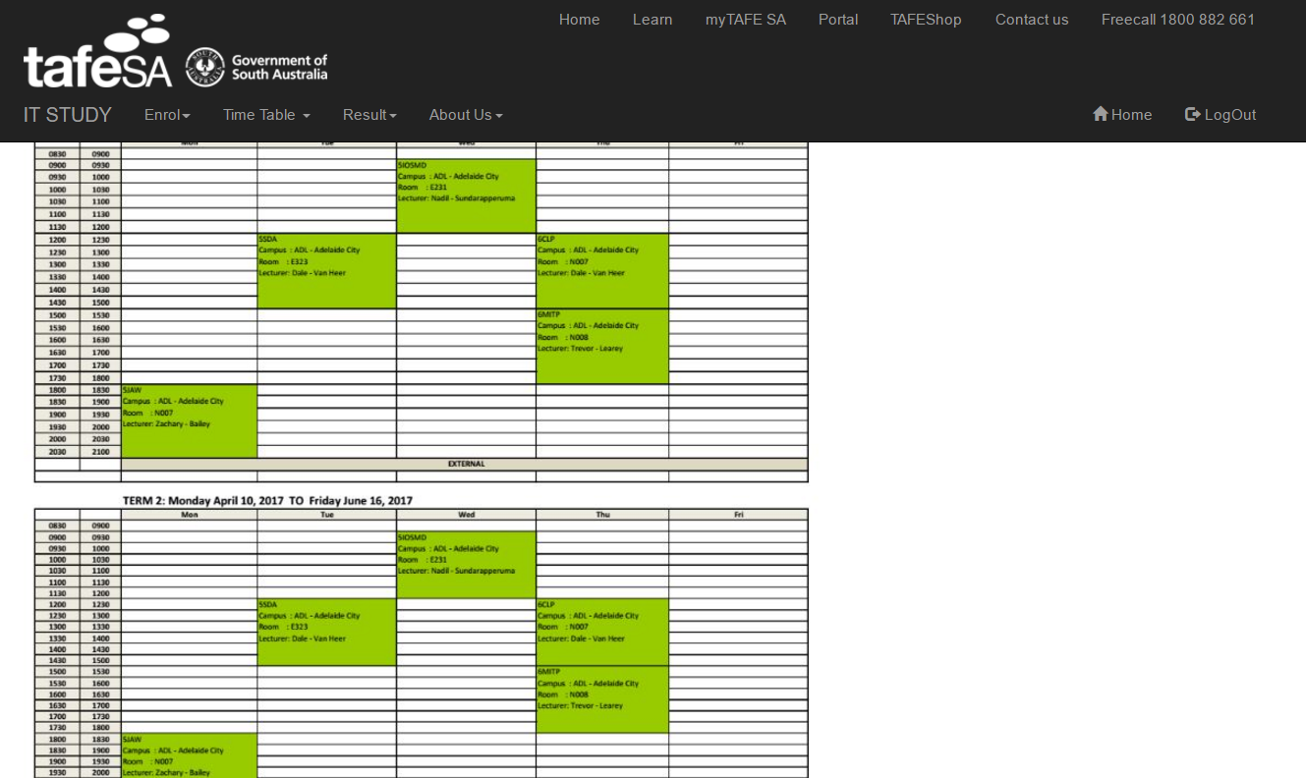

1. Result page

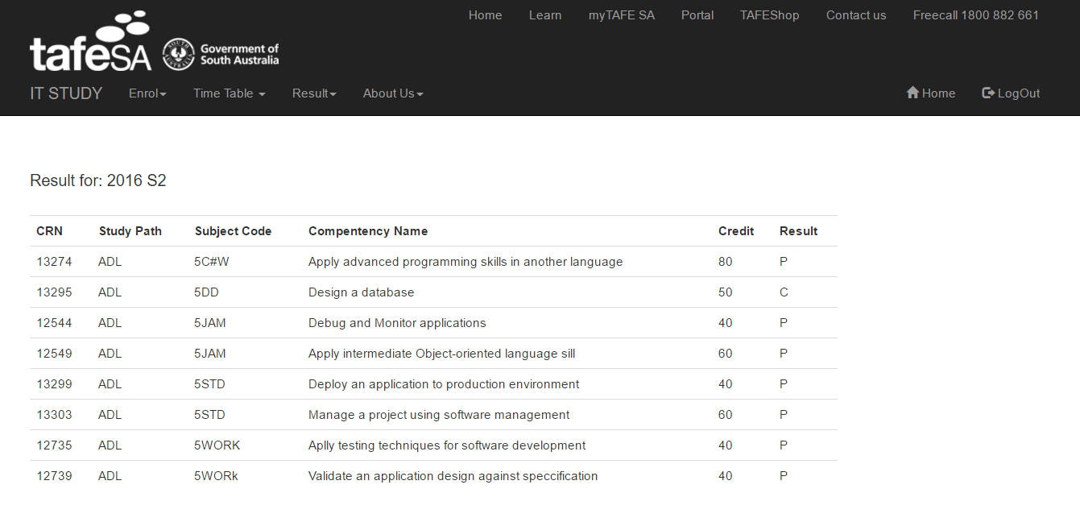

1. More information

All more information page is linked to TAFE SA website, where introduce the course respectively in IT faculty.